John Michael Go
Career Entry Level Java Programming
Date: Jan. 11, 2013

DAY 6

Program Name: FirstSwingGUI

Objective: Program outputs Swing GUI Form, Label and Button

Algorithm:

1. Program outputs Swing GUI Form, Label and Button.

Flowchart:

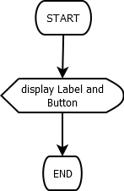
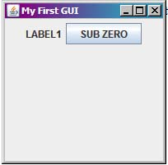

Pseudocode:

/* Program Name: FirstSwingGUI
Created By: John Michael Go
Creation Date: Jan. 18, 2013 Day 6
Note: Program displays GUI interface with labels and buttons.
*/
import javax.swing.*;

public class FirstSwingGUI {

public static void main(String[] args) {

JFrame frame = new JFrame("My First GUI");

frame.setVisible(true);
frame.setSize(200, 200);
frame.setDefaultCloseOperation(JFrame.EXIT_ON_CLOSE);

JLabel label = new JLabel("LABEL1");

JPanel panel = new JPanel();
frame.add(panel);
panel.add(label);

JButton button = new JButton ("SUB ZERO");
panel.add(button);
button.setLocation(50, 50);

} // end main

} // end class

Screenshot:

